Halloween Assignment

Text 1 - HISTORY OF HALLOWEEN
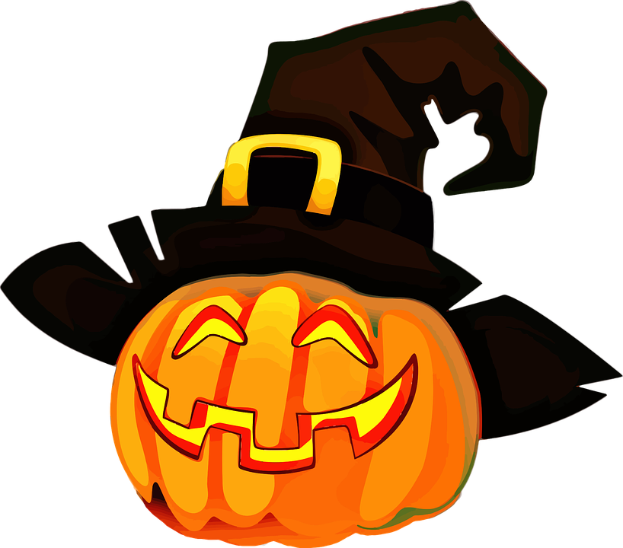
The Halloween we celebrate October 31st began long ago. They came from the ancient Celtic festival of Samhain. The Celtic people lived about 2,000 years ago in an area which we now call Ireland, the United Kingdom, and France. The festival of Samhain marked the end of summer, the harvest season, and the beginning of their new year. The Celtic people believed that on the night of October 31st , the ghosts of the dead returned to earth. They built huge bonfires and dressed in costumes to frighten the ghosts. The Celtics also offered the ghosts good things to eat.

The modern Halloween is similar to the customs of the Celtic people because many immigrants came to America and brought their beliefs and traditions with them. The carving of a Jack-O-Lantern is thought to come from the tradition of Irish children. They would carve potatoes or turnips and light them for their Halloween celebrations. The name Jack came from an Irish man who people thought was so wicked neither heaven or the devil wanted him. Jack is thought to have walked the earth looking for a place to rest.

Trick or Treating is thought to have come from the English people when they celebrated the religious festival of “All Saints Day.” On this day, the poor would beg for food and would be given “Soul Cakes”. Halloween in America is celebrated on October 31st. The celebrations are held in towns, schools, churches, and homes. Most children still dress in costumes and continue to trick or treat in safe neighborhoods or attend festivals at churches or schools.

- Translate the underlined words in the text!
Ancient
Harvest
Bonfires
Similar
Carving
Wicked
beg

- Answer these questions!
- The Celtic people lived_______________.
a. 2000 years ago b. in Spain c. in America

- Why is the modern celebration of Halloween similar to the customs of the Celtic people?
  - The Celtics lived in America.
  - The ghosts roamed the earth.
  - Immigrants came to America and brought their customs with them.
  - Many people do not celebrate Halloween.

- The custom of trick or treating came from what group of people?
a. The Irish b. The Spanish c. The English d. none of these

- Why was Jack not granted permission to live in heaven or with the devil?
a. He was so wicked b. He was too ugly.
c. He had potatoes . d. none of these

- Samhain marked the end of what?
a. summer b. end of a life
c. winter d. ghosts

- Where are the celebrations of Halloween held today?
a. homes b. churches c. schools d. all of these

- Which of the following is NOT true about the Celtic people?
  - They celebrated by making Jack-O-Lanterns.
  - They dressed in costumes.
  - They built bonfires.
  - They offered the ghosts good things to eat.

- Write down the names of the monsters on this monster guide!
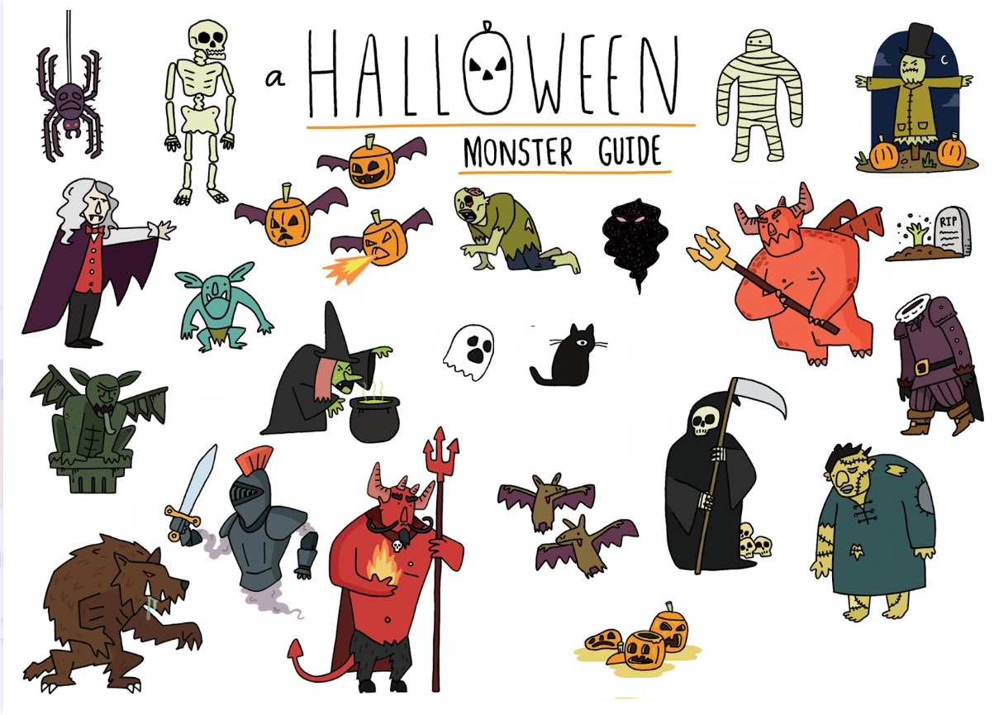
(For the turds who don’t understand, YES IN ENGLISH)

- Halloween Jokes. Match the question with the correct answer!
Q: How can you enter a haunted house?
A:

Q: How can you fatten up a ghost?
A:.

Q Why are black cats such good singers?
A:

Q. Why do witches wear name tags?
A

Q Why didn't the skeleton dance at the Halloween party
A:

Q: How can a witch tell the time?
A:.

Q: What is a ghost's favorite ride?
A:.
Answers:
They're very meeewsical
It had no body to dance with
With a skeleton key
With ghoulash and spooketti
A roller ghoster
It had no body to dance with
So, they would know which witch is which

- What is the word?
- It is the season of the year when the days get shorter, the leaves fall from the trees, and we celebrate Halloween.
What is this word? ___A____________

- It is a flying mammal (=zoogdier).
What is it called? __B_____________

- It is a thing you put over your face to pretend you are someone or something else.
What is it called? __M_____________

- It is a scary make-believe thing that is supposed to be the spirit of a dead person.
What is it called? ___G_______________

- It is an animal that has eight legs and a two-part body.
What is it? ____S_________________

- It is a sticky structure used to catch prey. It is made by the animal in the previous (=vorige) question.
What is this word? ____W___________

- It is a scary, make-believe woman with magical powers. They say she often flies on a broom!
What is this word? ______W____________

- It is a pumpkin that has been carved into a scary face.
What is it? ______J_______________________

- It is a set of bones.
What is it called? ______S_______________________

- It is a sweet treat that is given to trick-or-treating children at Halloween.
What is it? _____C____________

